

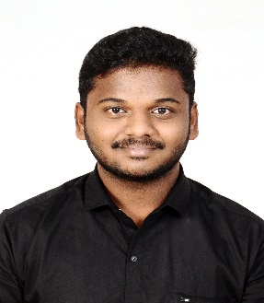**Kesavamoorthi M**

**CSD Intern**

Associate ID : 2318458

Email ID : [Kesavamoorthi.m@cognizant.com](mailto:Kesavamoorthi.m@cognizant.com)

Mobile : +91 9361470996

LinkedIn ID : <https://www.linkedin.com/in/kesavamoorthi-m-6517871ab>

**CAREER OBJECTIVE**

Self-motivated, highly passionate, hardworking java full stack developer looking for an opportunity to work in a challenging project to utilize my skills and knowledge to work for the growth of the organization.

**WORK EXPERIENCE**

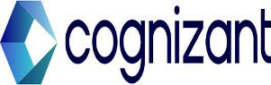 **CSD Trainee | 01 Dec 2023 – Present**

Currently undergoing training program on ADM Java Full Stack, gaining strong core and technical knowledge in the course.

**ACADEMIC QUALIFICATION**

* **Muthayammal Engineering College, Rasipuram**

BE, Electronics & Communication Engineering | Aug 2019 – 2023 | CGPA – 8.94

* **Paramveer Matriculation Higher Secondary School, Dharmapuri.**

Class 11TH & 12TH HSC | 2017 – 2019 | 436/600 (Bio-Maths)

* **Yesu Raja Matriculation School, Dharmapuri.**

Class LKG – 10TH SSLC | 2005 – 2017 | 471/500.

**PROFESSIONAL SKILLS**

* Software skills known: Working knowledge in Eclipse, SQL Workbench, Spring Tool Suite, GIT, Visual Studio Code, Postman.
* Programming skills known: Java, SQL, HTML, CSS, Spring Framework.
* Ability to adapt any environment and willingness to learn new things.
* Ability to work independently or as a part of a team.

**PROJECT WORK**

* **Voyage Link – The Transport Nexus**

**Software :** Spring Suite Tool, SQL Workbench, Postman, VS Code

Voyage link is an Online Transport Management System, it is a platform that connects customers and transport service vendors where customers can reach the available vendors in a particular location and vendors can use it to get the orders from customers and expand the business.

**ACHIEVEMENT**

* Won the “**Second rank cup on 12th standard**” in the hands of Moon man of India – Mylswamy Annadurai, Indian Scientist – ISRO.

**CERTIFICATIONS**

* Completed certification course on “**Java Full Stack**” by Talent Next and Wipro.
* Completed **HTML5 + CSS3** course on Udemy conducted through Cognizant Technology Solutions training.

**PERSONAL DETAILS**

* Languages Known : English, Tamil
* Domain Interests : Full Stack Development.